Jal Rekha

High Level Design (HLD)

30-JAN-2026



Madhya Pradesh State Electronics Development Cooperation State IT Centre, 47-A, Arera Hills, Bhopal
https://mpsedc.mp.gov.in/

High Level Design (HLD)
Jal Rekha Project – Nirmal Module (Water Quality Monitoring)

Organization: Madhya Pradesh State Electronics Development Corporation (MPSEDC)
Client: MP Jal Nigam Maryadit
Document Type: High Level Design Document

1. Overview
Ensuring accurate monitoring of water supply and distribution is essential for efficient water resource management and service delivery. The Dhara Module within the Jal Rekha system is designed to capture, validate, and report water supply meter readings across schemes, treatment plants, storage units, and bulk supply points.
The module follows a mobile-assisted, web-governed workflow:
- Field Engineers (FE) are assigned specific schemes and OHT/village components by the General Manager (GM).
- FEs collect and submit meter readings through a mobile application.
- The GM reviews submitted readings on the web portal, with the authority to edit readings (with remarks), approve, or reject.
- Only GM-approved readings are used for generating official water supply reports.
All scheme, village, and OHT mappings are performed through the web system before task assignment, ensuring that field data collection is always aligned with verified infrastructure records.
By digitizing the meter reading and approval process, the Dhara module improves data accuracy, operational transparency, accountability, and timely reporting for water supply management. The module also supports state digital governance goals by enabling centralized monitoring, audit trails, and data-driven decision-making.

2. System Architecture
The Dhara module follows a centralized web and mobile integrated architecture
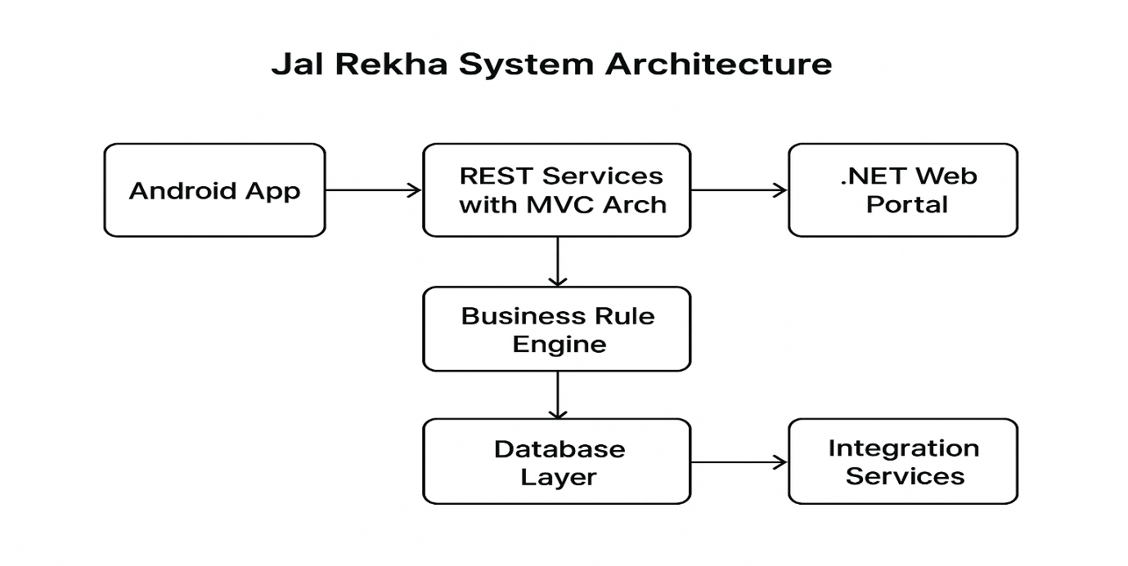
2.1 Architecture Style
Presentation Layer
- Web Portal (GM/Admin users)
- Mobile Application (Field Engineers)
Application Layer
- Task Management Service
- Survey & Meter Reading Service
- Approval Workflow Engine
- Reporting & MIS Service
Data Layer
- Central Jal Rekha Database storing mapping, task, survey, and report data

3. Module Workflow – Dhara Module
The Dhara Module operates in the following stages:
3.1 Infrastructure Mapping (Web)
Before surveys can be conducted, the following mappings must be configured:
- Scheme to Village Mapping
- OHT to Village & Habitation Mapping
- Classification of villages (O&M Declared / Water Supply Started / Bulk Village)
These mappings ensure surveys are performed only on valid infrastructure.

3.2 Task Assignment (Web)
• GM selects scheme, village, and OHT
• GM assigns survey tasks to Field Engineers
• Assigned tasks are made available in the FE mobile app

3.3 Meter Reading Survey (Mobile)
Field Engineers perform surveys using the mobile app:
• View assigned tasks
• Enter meter readings for:
- Intake Meter
- WTP Meter
- OHT Meter
- Bulk Meter
• Add remarks and supporting details
• Submit survey
Data is validated and synchronized with the central server.

3.4 Review and Approval (Web)
• GM views submitted readings
• GM can edit readings with mandatory remarks
• GM approves or rejects the survey
• Only approved readings move to reporting layer
All changes are logged for audit tracking.

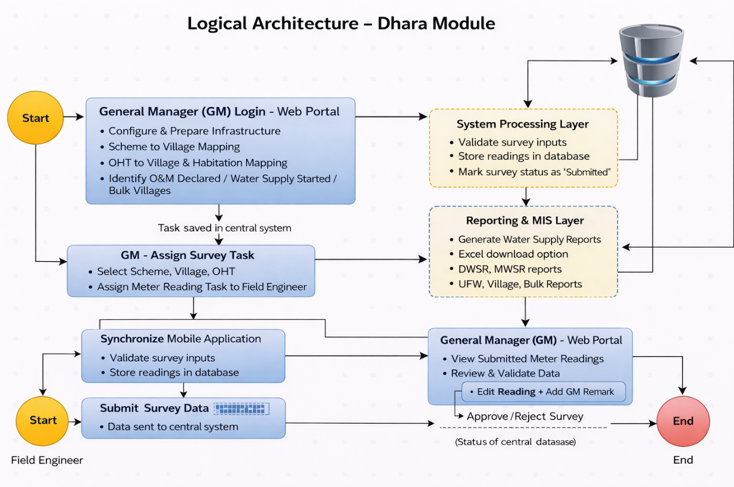
Fig: logical architecture

4. Reports
The module provides the following reports based on approved readings:
• Intake Meter Reading Report
• WTP Meter Reading Report
• OHT Meter Reading Report
• Bulk Meter Reading Report
• Daily Water Supply Report (DWSR)
• Monthly Water Supply Report (MWSR)
• UFW Report
• Scheme-wise Water Supply Report
• Village-wise Monthly Water Supply Report
• Bulk User Monthly Report
All reports include Excel export functionality.

5. Project Components
- Frontend: ASP.NET (Web Dashboard, GIS Visualization)
- Mobile Application: Android (Core Java/Kotlin)
  - Offline Sync using SQLite / Local Storage
- Backend: RESTful WCF Services (.NET)
- Database: PostgreSQL with PostGIS (Spatial Data)
- Web Server: IIS
- Authentication: JWT Tokens
- Authorization: Role-Based Access Control (RBAC)

Web Portal (.NET-Based Front End)
- The Jal Rekha Web Portal is developed on the .NET framework, designed for department officials, administrators, and higher authorities.
- It enables planning, monitoring, approvals, task assignments, and progress tracking of water supply schemes.
- The web portal interacts seamlessly with the same RESTful services used by the mobile application, ensuring real-time synchronization of data across platforms.
- Authorized users can manage user roles, approve RFIs, generate reports, and access GIS-based dashboards through the portal.

Android-Based Mobile Front End
- The Jal Rekha Mobile Application is developed on Android to enable field-level data collection, asset mapping, inspection reporting, RFI submissions, and progress monitoring.
- The mobile application communicates with the RESTful services built using the MVC (Model-View-Controller) architecture.
- Field engineers, contractors, and other on-site users primarily interact with Jal Rekha through the mobile app.
- Future front-end applications, such as an iOS app, can also be integrated within the same architecture, but user onboarding and authentication will primarily be managed via the Android application.

REST Services with MVC Architecture
- Jal Rekha follows a decoupled RESTful architecture, allowing mobile apps, the web portal, and other integrated systems to interact independently.
- The MVC structure ensures modular development and simplifies testing, maintenance, and future scalability.
- Both the Android app and the .NET web portal communicate with these REST services after successful authentication.
- Token-based authorization is implemented at the application level to secure data exchange and user operations.

Business Rule Engine (BRE)
- The Business Rule Engine governs all workflows, validations, and approval processes within Jal Rekha.
- All rules, roles, and privileges are defined at the database level, ensuring centralized control over system operations.
- User permissions are dynamically assigned based on their roles, enabling controlled access to modules like asset mapping, inspections, approvals, reporting, and dashboards.

Database Layer
- The database layer securely manages all datasets required across the Jal Rekha platform, including user profiles, asset data, inspection details, RFI status, and scheme information.
- Data is stored using Object Relational Mapping (ORM) techniques for seamless integration between applications and the database.
- The database is synchronized between the primary server and integrated application services to ensure real-time data availability.
- Role-based access controls and privileges are also maintained at the database level to secure user operations.

Integration Services
- Jal Rekha supports integration with third-party services for better user experience and operational efficiency.
- Email services are integrated for user registration, password resets, profile updates, and notification alerts.
- Planned future integrations include:
  - SMS gateways for status updates and reminders
  - GIS-based services for advanced mapping and visualization
  - Analytics tools for insights, reporting, and performance monitoring
  - Samagra integration to Enter the Samagra ID & mobile no for beneficiary.

6. Data Flow Diagram (DFD)
6.1 Context Level DFD (Level 0)
This diagram represents the high-level interaction between external users and the Dhara System.
Field Engineer / General Manager (GM)
↓
Dhara Module (Jal Rekha System)
↓
PostgreSQL Database
Description
- Field Engineers submit meter readings through the mobile application.
- General Managers assign tasks, review, edit, approve, and generate reports through the web portal.
- The Dhara system processes all inputs and stores validated data in the centralized PostgreSQL database.
6.2 Level 1 DFD
This diagram breaks down the internal processing of the Dhara Module.
General Manager (GM)
↓
Task Assignment Process
↓
Survey Task Database

Field Engineer (FE)
↓
Meter Reading Submission Process
↓
Survey Data Database

General Manager (GM)
↓
Review & Approval Process
↓
Approved Data Store

Reporting Module
↓
Water Supply Reports (DWSR, MWSR, UFW, Scheme-wise, Village-wise, Bulk User Reports)
↓
Central PostgreSQL Database
Process Descriptions
A. Task Assignment Process
GM assigns meter survey tasks based on mapped scheme, village, and OHT data.
B. Meter Reading Submission Process
Field Engineers capture and submit meter readings via mobile app.
C. Review & Approval Process
GM validates readings, edits with remarks if required, and approves or rejects the survey.
D. Reporting Process
Approved readings are used to generate operational and analytical reports.

7. User Roles
Role | Description
General Manager (GM) | Assigns tasks, reviews and edits readings, approves/rejects surveys, generates reports
Field Engineer (FE) | Receives tasks and submits meter readings via mobile app

8. Data Governance & Controls
• Role-based access control
• FE can only access assigned tasks
• GM approval mandatory for reporting
• Audit trail maintained for edits and approvals

9. Integration Points
Dhara Module integrates with:
• Jal Rekha Master Data (Scheme, Village, OHT)
• User Management Module
• Reporting & MIS Module

10. Security
- JWT-based authentication
- Authentication & authorization
- Role-Based Access Control (RBAC)
- Secure HTTPS communication
- API-level input validation
- Audit logging for critical actions

11. Benefits
• Accurate and timely meter data capture
• Reduced manual errors
• Strong approval governance
• Transparent reporting
• Improved decision-making for water supply management

